

For more information

“The European Union is made up of 28 Member States who have decided to gradually link together their know-how, resources and destinies. Together, during a period of enlargement of 50 years, they have built a zone of stability, democracy and sustainable development whilst maintaining cultural diversity, tolerance and individual freedoms.

The European Union is committed to sharing its achievements and its values with countries and peoples beyond its borders”.

The European Commission
is the EU’s executive body.

http://europa.eu

.

The European Union’s Management Training Programme for the Republic of Uzbekistan
Management Training Programme (MTP)
Address : 4th avenue, Amir Temur street, Tashkent city, 100047, Uzbekistan
Tel : (99871) 233-5901 Fax : (99871) 233-6406
E-mail : mtp@mtpeu.uz Web site : www.mtpeu.uz

Chamber of Commerce and Industry of Uzbekistan
Address : 4th avenue, Amir Temur street, Tashkent city, 100047, Uzbekistan
Tel/Fax: (99871) 150-6000
E-mail : info@chamber.uz Web site : www.chamber.uz

European Profiles S.A.
Address : 40 Vatatzi Street, 114 72 Athens, Greece
Tel :+30 210 82 10 895 Fax :+30 210 82 54 021
E-mail : epmail@europeanprofiles.gr
Web site : www.europeanprofiles.gr

Management Training Programme (MTP) - Capacity Building for SME Management in Uzbekistan

BUILDING PARTNERSHIPS BETWEEN ITALIAN AND UZBEK COMPANIES

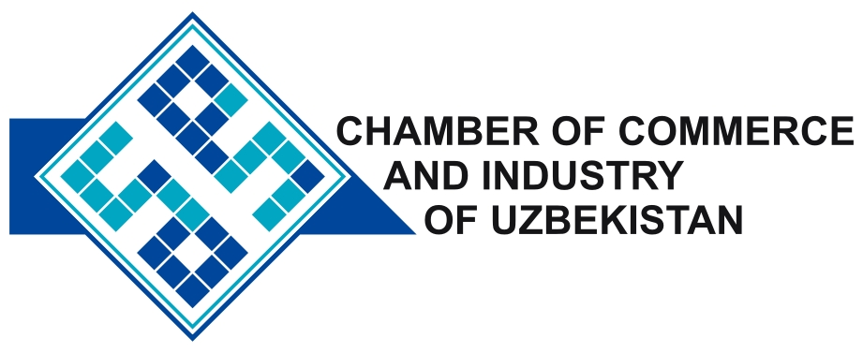

A project implemented by a Consortium
led by European Profiles S.A.
(CONTRACTOR)

This programme is implemented by a Consortium led by European Profiles S.A. The views expressed in this publication do not necessarily reflect the views of the European Commission
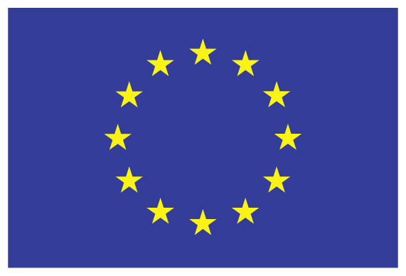
This project is funded by
The European Union


The EU funded Project “Management Training Programme (MTP)”
BUILDING PARTNERSHIPS BETWEEN ITALIAN AND UZBEK COMPANIES

WHAT ARE THE BENEFITS FOR ITALIAN COMPANIES?

Italian Companies participating in the programme, by hosting Uzbek managers will benefit from the opportunity to:

- Network, build strong new business partnerships and mutual trust, which is the most significant aspect of business in Uzbekistan and Central Asia;
- Learn about Uzbekistan and CIS markets and expand your business opportunities;
- Access to another Central Asia and CIS markets via existing networks of the partner company (from which the intern comes) in Uzbekistan;
- Interact with managers or entrepreneurs from other companies in Uzbekistan and get opportunities to collaborate with them;
- Work with an energetic and motivated manager or entrepreneur who can contribute to your business as a "fresh eye" on your business;
- Open a new emerging market for your goods and/or services;
- Create bilateral investment opportunities, potential for joint manufacturing, subcontracting and other projects.

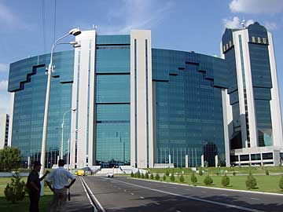

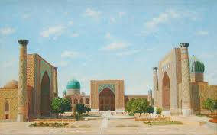
About the Project

The project “Management Training Programme – Capacity Building for SME Management in Uzbekistan” is funded by the European Union and executed by the consortium led by European Profiles S.A., Greece and consists of WYG International Limited, United Kingdom, CCI Paris Ile-de-France, Birmingham Chamber of Commerce (BCI), United Kingdom, PLANET S.A., Greece, Anticrisis Management Consulting (AMC), Uzbekistan, during August 2013 – August 2016. The Chamber of Commerce and Industry of the Republic of Uzbekistan is a local project partner.

The overall objective of the project is to contribute to the improvement of the performance of the SME sector in the Republic of Uzbekistan. In order to achieve the goals of the project, as one of the project components, it is planned to organize practical internships for selected managers from leading private sector companies, in the EU companies

Internships build partnerships

Internships of Uzbek managers in EU companies is one of the main components of the MTP project.
The internships will create unique opportunity for the establishment of direct business relationships between hosting EU companies and the companies in Uzbekistan. The interns (the managers) will spend up to 4 weeks in the hosting company to explore the potential opportunities for collaboration with hosting company (equipment purchase, investment, trade, manufacturing, know-how exchange, etc.) and learn existing business management techniques in the company for following application in their home companies*.

Potential benefits for host companies in Italy

About Uzbekistan
Republic of Uzbekistan is one of the fastest growing economies in Central Asia (about 8% of yearly GDP growth during last decade) with a consumer market of more than 30 million people.
____________________________
*All the expenses related to participation of selected Uzbek Managers in the internships are covered by MTP project.
As the welfare of the population in the country is increasing year by year, there is also strong growth of demand for new goods and services.

During last two decades, the Republic of Uzbekistan has formed a favourable investment environment, broad system of legal guarantees and privileges for foreign investors, developed integral system of measures on encouragement of activity of the enterprises with foreign investments. As the country is located in the crossroads of Central Asia, this creates favourable conditions for the development of regional cooperation, participation in regional and transnational projects of transport corridors development. It is a free trade zone with CIS countries. Proximity to the vast trade markets and developed transportation infrastructure of Uzbekistan, integrated into the multimodal Eurasia communication system, also designate the prospects of investment, trade and economic cooperation. Working in Uzbekistan, foreign companies are able to enter the five largest and fastest growing markets: CIS (with a market of over 300 million people), Central and Eastern Europe, South-East Asia, Middle East. The developed multimodal network significantly saves time and costs of delivery from Uzbekistan.

A full practical information and guide about Uzbekistan, its economy and investment opportunities could be found via “Invest in Uzbekistan 2013” guide prepared by the United Nations Development Program:

http://www.uz.undp.org/content/dam/uzbekistan/docs/Publications/Invest%20Uzbikistan.pdf

